# CCET 3680 Mill Lesson 4 Second Exercise

I. Wireframe:

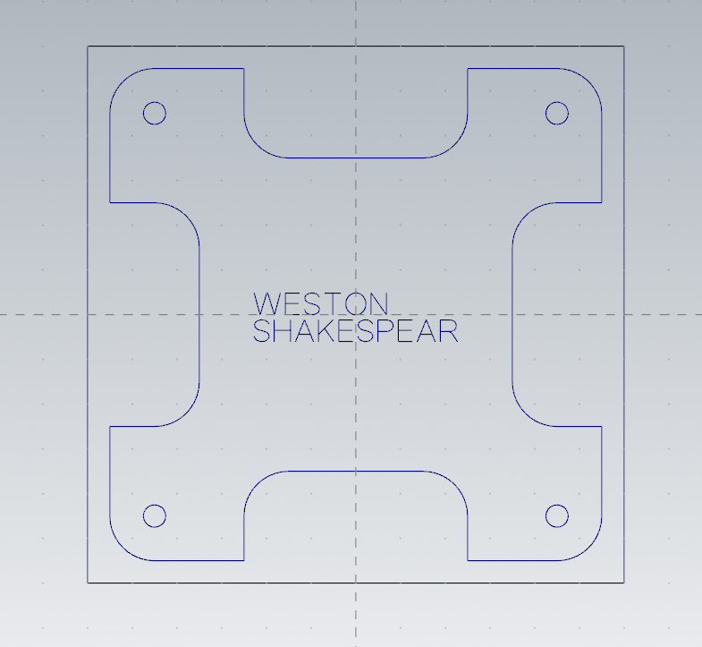

II. Dimensions:

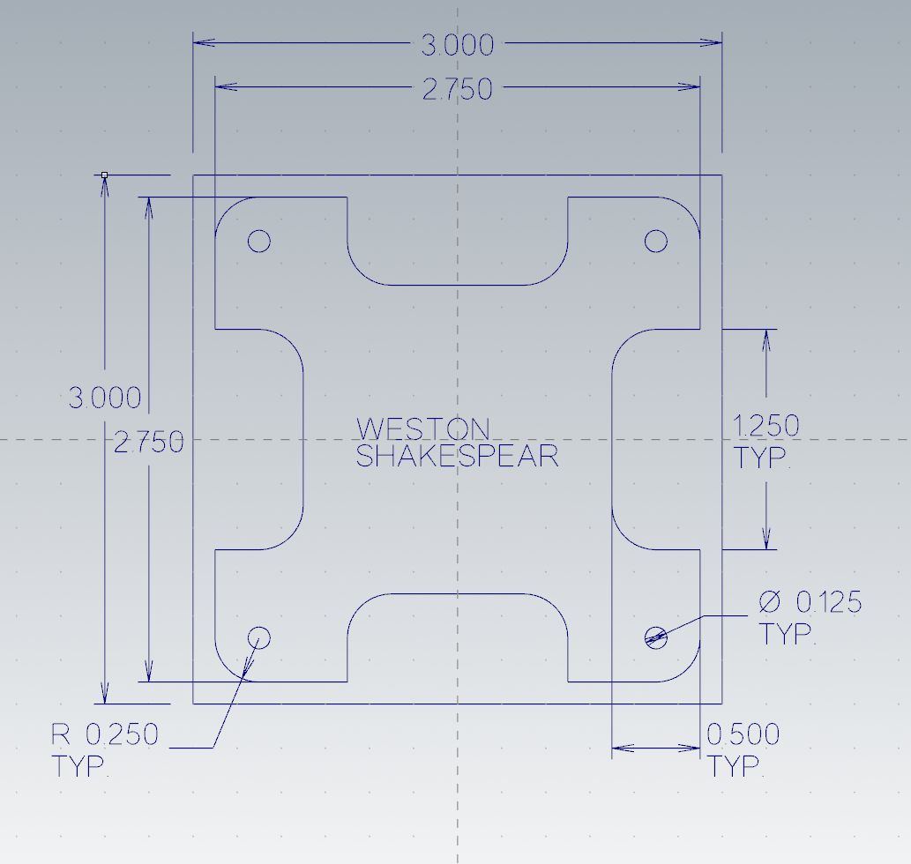

III. Solid:

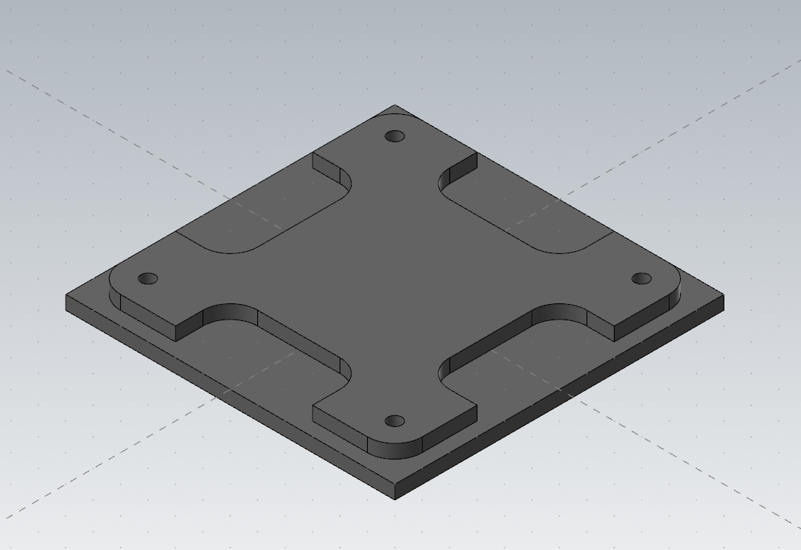

IV. Toolpaths:

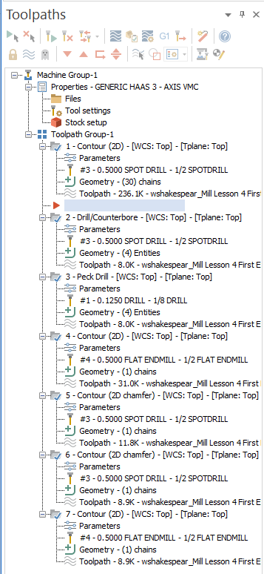

V. Name 2D Contour:

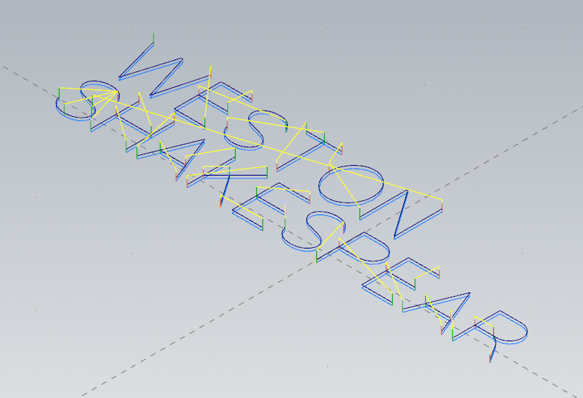

VI. Spot Drill:

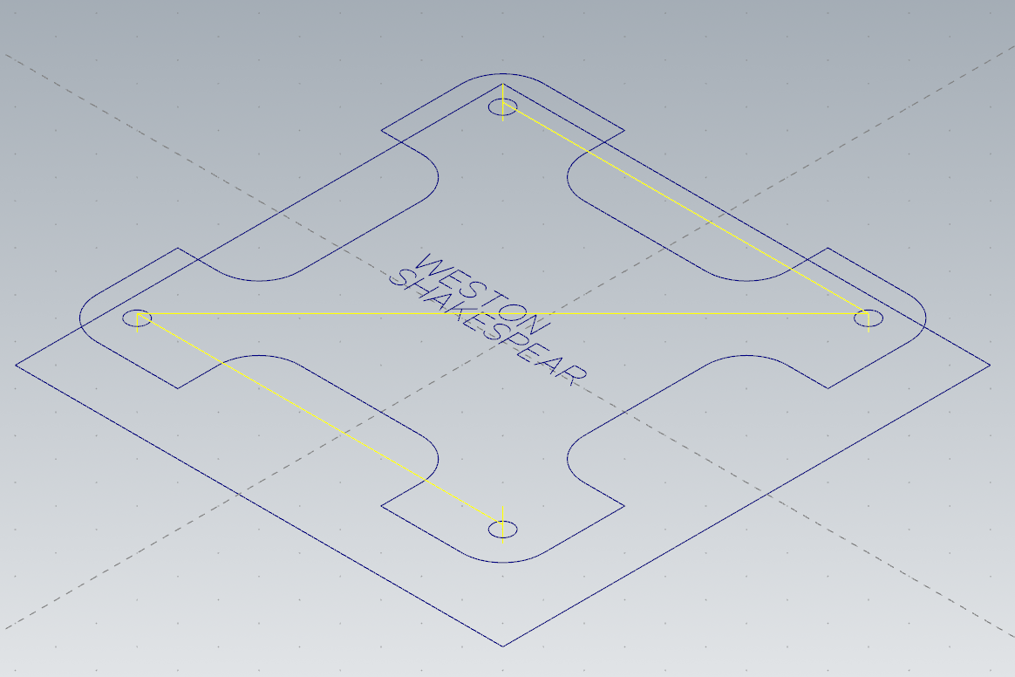

VII. Peck Drill:

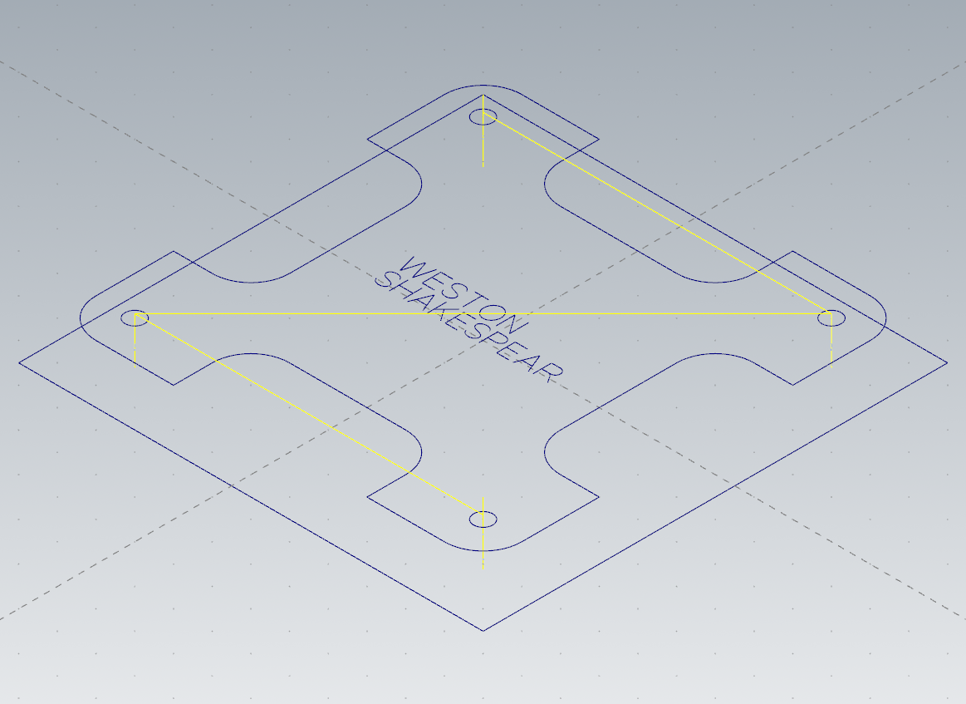

VIII. 2D Contour:

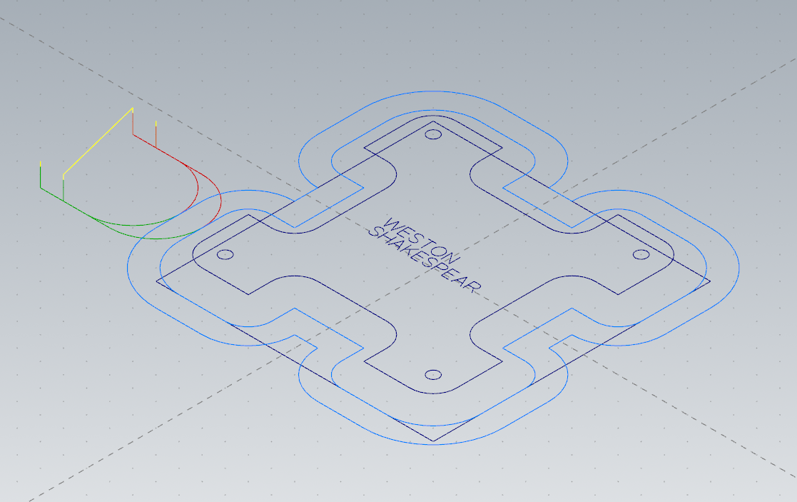

IX. 2D Chamfer Contour:

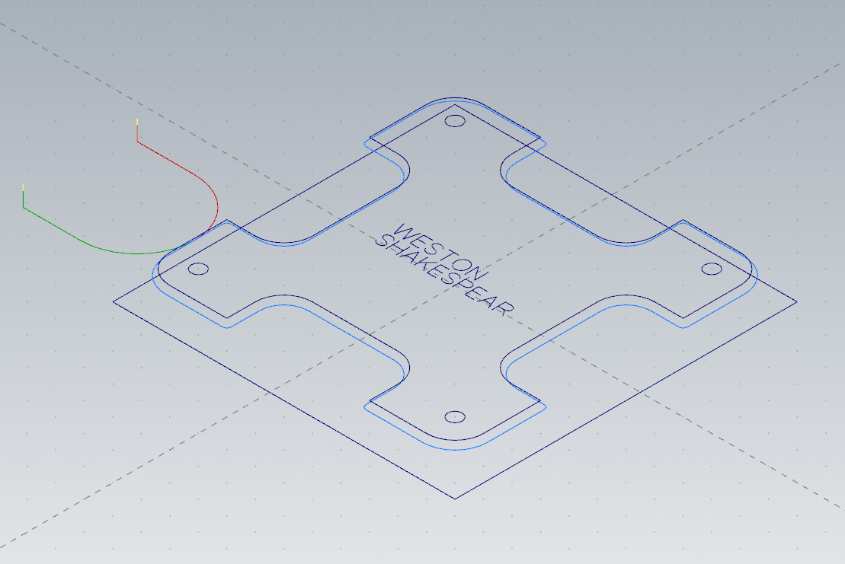

X: 2D Chamfer Contour:

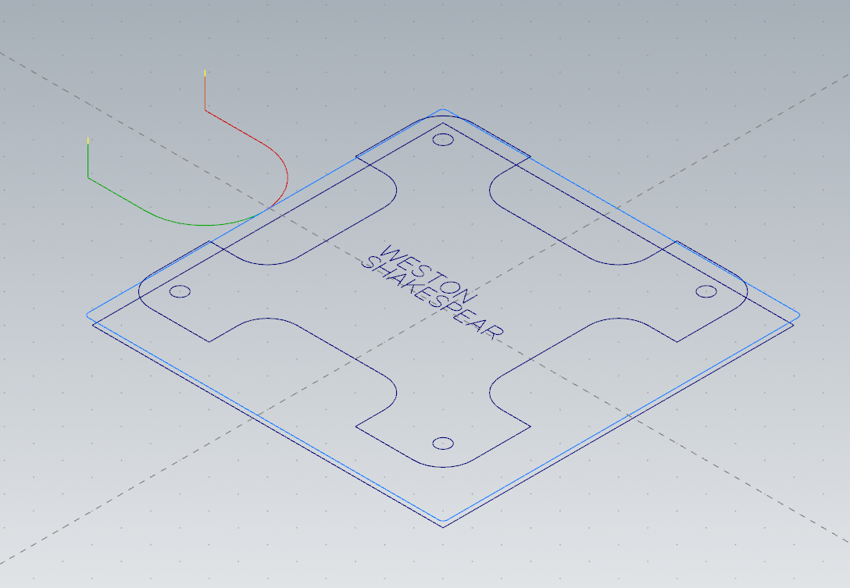

XI: 2D Contour:

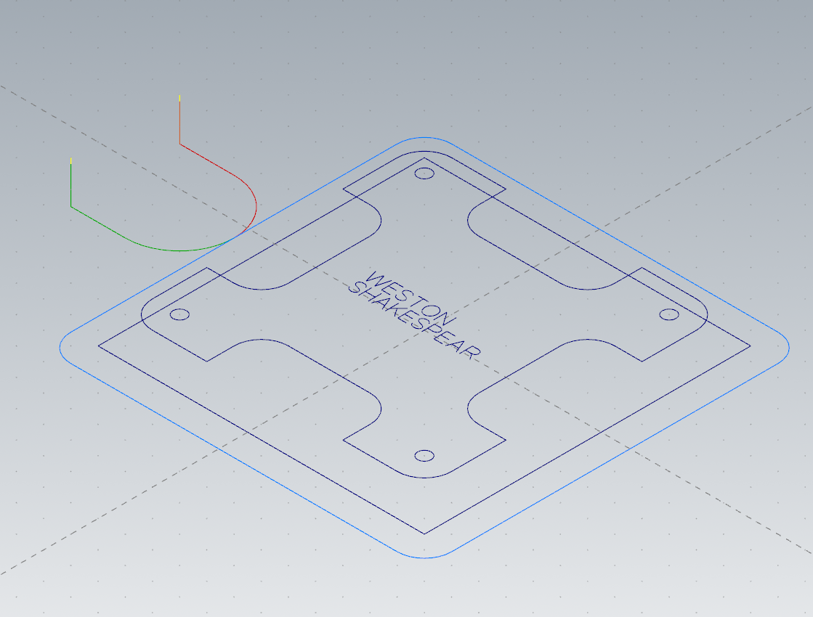

XII. Final Solid:

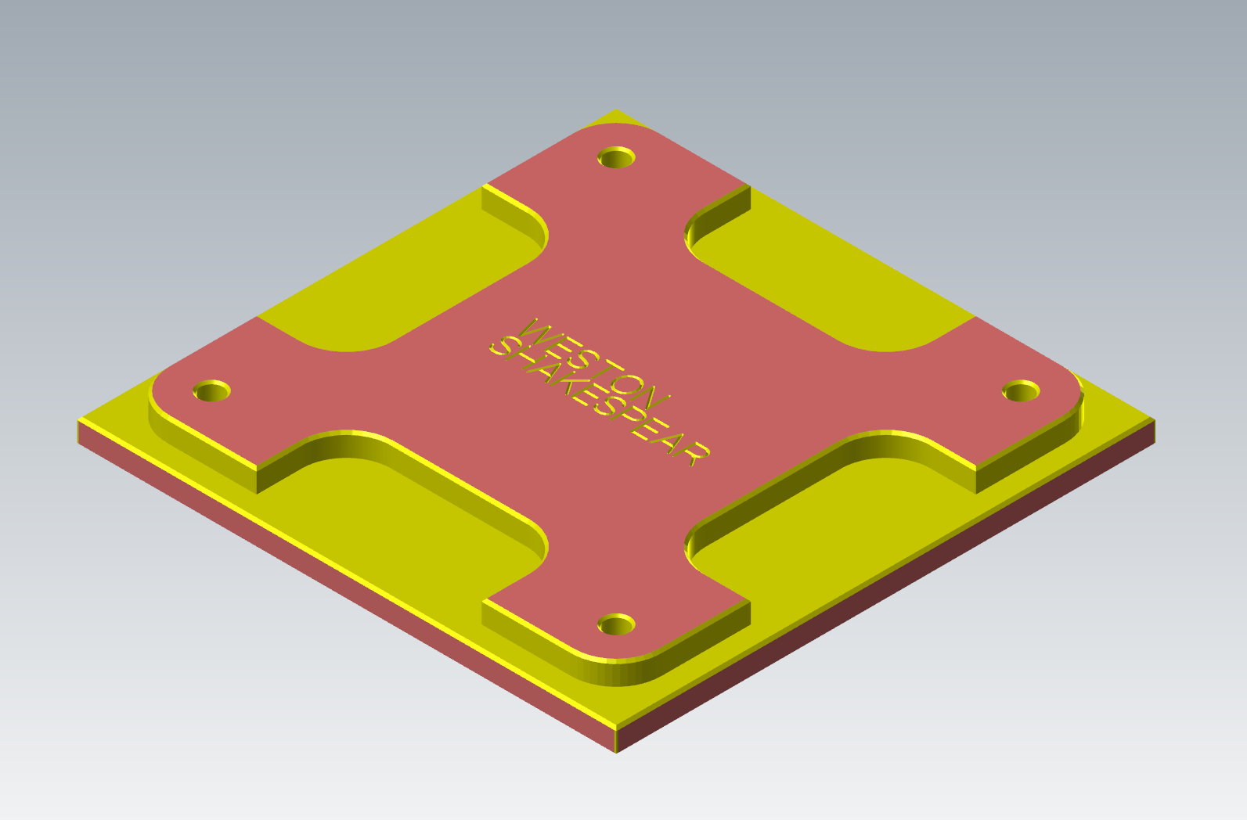

XIII. Method:

I drew two center anchored rectangles and then used offsets to create one copy of the repeating geometry. I then used the rotate tool to create four copies of the wireframe around the center.

XIV. GCode Changes

To modify my gcode to be compatible with the machine I first made sure the HAAS 3 axis post processor was selected when exporting the gcode. Then I removed the long lines at the beginning and edited the last G28 home command to not zero the x axis.

XV. Gcode:

%

O33001

(WSHAKESPEAR_MILL LESSON 4 SECOND EXERCISE)

(DATE=DD-MM-YY - 30-01-23 TIME=HH:MM - 12:04)

(MCAM FILE - C:\USERS\WESTONSHAKESPEAR\DOWNLOADS\WSHAKESPEAR_MILL LESSON 4 SECO)

(NC FILE - F:\CCET3680\NC\WSHAKESPEAR_MILL LESSON 4 SECOND EXERCISE.NC)

(MATERIAL - ALUMINUM INCH - 6061)

(T3|1/2 SPOTDRILL|H3|D3|TOOL DIA. - .5)

(T1|1/8 DRILL|H1|D1|TOOL DIA. - .125)

(T4|1/2 FLAT ENDMILL|H4|D4|TOOL DIA. - .5)

N100 G20

N110 G0 G17 G40 G49 G80 G90

N120 T3 M6

N130 G187 P3 E.001

N140 G0 G90 G54 X-.5682 Y.1221 S4966 M3

N150 G43 H3 Z.145

N160 G1 Z.118 F6.4

N170 X-.5347 Y-.0017 F500.

N180 X-.4972 Y.1221

N190 X-.4926

N200 X-.455 Y-.0017

N210 X-.4216 Y.1221

N220 Z.138 F6.4

N230 G0 Z.145

N240 X-.3145 Y0.

N250 G1 Z.118

N260 X-.3935 F500.

N270 Y.1203

N280 X-.3145

N290 Z.138 F6.4

N300 G0 Z.145

N310 X-.3191 Y.0628

N320 G1 Z.118

N330 X-.3935 F500.

N340 Z.138 F6.4

N350 G0 Z.145

N360 X-.2045 Y.0971

N370 G1 Z.118

N380 X-.2102 Y.1072 F500.

N390 X-.2193 Y.1149

N400 X-.231 Y.1195

N410 X-.2442 Y.1208

N420 X-.2599 Y.1186

N430 X-.2726 Y.1128

N440 X-.2815 Y.1037

N450 X-.2848 Y.0929

N460 X-.2808 Y.0791

N470 X-.2797 Y.0776

N480 X-.2677 Y.068

N490 X-.2622 Y.0654

N500 X-.2284 Y.056

N510 X-.2138 Y.0488

N520 X-.2096 Y.0448

N530 X-.204 Y.0343

N540 X-.2034 Y.0294

N550 X-.2066 Y.0185

N560 X-.2151 Y.0088

N570 X-.2278 Y.0022

N580 X-.2442 Y0.

N590 X-.2571 Y.0014

N600 X-.2687 Y.0055

N610 X-.2778 Y.0123

N620 X-.2833 Y.0205

N630 X-.2866 Y.0293

N640 Z.138 F6.4

N650 G0 Z.145

N660 X-.1288 Y.1203

N670 G1 Z.118

N680 Y-.0017 F500.

N690 Z.138 F6.4

N700 G0 Z.145

N710 X-.1747 Y.1203

N720 G1 Z.118

N730 X-.0835 F500.

N740 Z.138 F6.4

N750 G0 Z.145

N760 X-.0557 Y.0599

N770 G1 Z.118

N780 X-.0517 Y.0826 F500.

N790 X-.0513 Y.0838

N800 X-.0394 Y.103

N810 X-.0391 Y.1033

N820 X-.0233 Y.1155

N830 X-.0213 Y.1165

N840 X-.0024 Y.1214

N850 X.0007 Y.1215

N860 X.02 Y.1175

N870 X.0221 Y.1165

N880 X.0383 Y.1049

N890 X.0399 Y.1033

N900 X.0515 Y.0852

N910 X.0521 Y.0838

N920 X.0565 Y.0615

N930 Y.0599

N940 X.0525 Y.0373

N950 X.0521 Y.0362

N960 X.04 Y.0168

N970 X.0399 Y.0167

N980 X.0228 Y.0038

N990 X.0221 Y.0035

N1000 X.0026 Y-.0011

N1010 X.0007 Y-.0012

N1020 X-.0172 Y.0018

N1030 X-.0213 Y.0035

N1040 X-.0383 Y.0158

N1050 X-.0391 Y.0167

N1060 X-.0512 Y.036

N1070 X-.0513 Y.0362

N1080 X-.0557 Y.0578

N1090 Y.0599

N1100 Z.138 F6.4

N1110 G0 Z.145

N1120 X.0847 Y-.0017

N1130 G1 Z.118

N1140 Y.1221 F500.

N1150 X.1719 Y-.0017

N1160 Y.1221

N1170 Z.138 F6.4

N1180 G0 Z.145

N1190 X-.5095 Y-.094

N1200 G1 Z.118

N1210 X-.5432 Y-.0846 F500.

N1220 X-.5571 Y-.0764

N1230 X-.5608 Y-.0724

N1240 X-.5646 Y-.0652

N1250 X-.5659 Y-.0571

N1260 X-.5625 Y-.0463

N1270 X-.5537 Y-.0372

N1280 X-.541 Y-.0314

N1290 X-.5253 Y-.0292

N1300 X-.5121 Y-.0305

N1310 X-.5004 Y-.0351

N1320 X-.4912 Y-.0428

N1330 X-.4856 Y-.0529

N1340 Z.138 F6.4

N1350 G0 Z.145

N1360 X-.4845 Y-.1206

N1370 G1 Z.118

N1380 X-.4885 Y-.1079 F500.

N1390 X-.4907 Y-.1052

N1400 X-.4984 Y-.0988

N1410 X-.5095 Y-.094

N1420 X-.5432 Y-.0846

N1430 X-.5571 Y-.0764

N1440 X-.5608 Y-.0724

N1450 X-.5646 Y-.0652

N1460 X-.5659 Y-.0571

N1470 X-.5625 Y-.0463

N1480 X-.5537 Y-.0372

N1490 X-.541 Y-.0314

N1500 X-.5253 Y-.0292

N1510 X-.5121 Y-.0305

N1520 X-.5004 Y-.0351

N1530 X-.4912 Y-.0428

N1540 X-.4856 Y-.0529

N1550 Z.138 F6.4

N1560 G0 Z.145

N1570 X-.5253 Y-.15

N1580 G1 Z.118

N1590 X-.5089 Y-.1478 F500.

N1600 X-.4962 Y-.1412

N1610 X-.4877 Y-.1315

N1620 X-.4845 Y-.1206

N1630 X-.4885 Y-.1079

N1640 X-.4907 Y-.1052

N1650 X-.4984 Y-.0988

N1660 X-.5095 Y-.094

N1670 X-.5432 Y-.0846

N1680 X-.5571 Y-.0764

N1690 X-.5608 Y-.0724

N1700 X-.5646 Y-.0652

N1710 X-.5659 Y-.0571

N1720 X-.5625 Y-.0463

N1730 X-.5537 Y-.0372

N1740 X-.541 Y-.0314

N1750 X-.5253 Y-.0292

N1760 X-.5121 Y-.0305

N1770 X-.5004 Y-.0351

N1780 X-.4912 Y-.0428

N1790 X-.4856 Y-.0529

N1800 Z.138 F6.4

N1810 G0 Z.145

N1820 X-.5677 Y-.1207

N1830 G1 Z.118

N1840 X-.5643 Y-.1295 F500.

N1850 X-.5589 Y-.1377

N1860 X-.5498 Y-.1445

N1870 X-.5382 Y-.1486

N1880 X-.5253 Y-.15

N1890 X-.5089 Y-.1478

N1900 X-.4962 Y-.1412

N1910 X-.4877 Y-.1315

N1920 X-.4845 Y-.1206

N1930 X-.4885 Y-.1079

N1940 X-.4907 Y-.1052

N1950 X-.4984 Y-.0988

N1960 X-.5095 Y-.094

N1970 X-.5432 Y-.0846

N1980 X-.5571 Y-.0764

N1990 X-.5608 Y-.0724

N2000 X-.5646 Y-.0652

N2010 X-.5659 Y-.0571

N2020 X-.5625 Y-.0463

N2030 X-.5537 Y-.0372

N2040 X-.541 Y-.0314

N2050 X-.5253 Y-.0292

N2060 X-.5121 Y-.0305

N2070 X-.5004 Y-.0351

N2080 X-.4912 Y-.0428

N2090 X-.4856 Y-.0529

N2100 Z.138 F6.4

N2110 G0 Z.145

N2120 X-.4559 Y-.1517

N2130 G1 Z.118

N2140 Y-.0279 F500.

N2150 Z.138 F6.4

N2160 G0 Z.145

N2170 X-.3652 Y-.0872

N2180 G1 Z.118

N2190 X-.4559 F500.

N2200 Z.138 F6.4

N2210 G0 Z.145

N2220 X-.3652 Y-.1517

N2230 G1 Z.118

N2240 Y-.0279 F500.

N2250 Z.138 F6.4

N2260 G0 Z.145

N2270 X-.3371 Y-.1517

N2280 G1 Z.118

N2290 X-.287 Y-.0279 F500.

N2300 X-.237 Y-.1517

N2310 Z.138 F6.4

N2320 G0 Z.145

N2330 X-.3197 Y-.1099

N2340 G1 Z.118

N2350 X-.2544 F500.

N2360 Z.138 F6.4

N2370 G0 Z.145

N2380 X-.2087 Y-.0279

N2390 G1 Z.118

N2400 Y-.1517 F500.

N2410 Z.138 F6.4

N2420 G0 Z.145

N2430 X-.1268 Y-.0279

N2440 G1 Z.118

N2450 X-.2087 Y-.1099 F500.

N2460 Z.138 F6.4

N2470 G0 Z.145

N2480 X-.1753 Y-.0765

N2490 G1 Z.118

N2500 X-.1228 Y-.1517 F500.

N2510 Z.138 F6.4

N2520 G0 Z.145

N2530 X-.0161 Y-.15

N2540 G1 Z.118

N2550 X-.0951 F500.

N2560 Y-.0297

N2570 X-.0161

N2580 Z.138 F6.4

N2590 G0 Z.145

N2600 X-.0951 Y-.0872

N2610 G1 Z.118

N2620 X-.0207 F500.

N2630 Z.138 F6.4

N2640 G0 Z.145

N2650 X.0118 Y-.1207

N2660 G1 Z.118

N2670 X.0152 Y-.1295 F500.

N2680 X.0206 Y-.1377

N2690 X.0298 Y-.1445

N2700 X.0413 Y-.1486

N2710 X.0542 Y-.15

N2720 X.0706 Y-.1478

N2730 X.0833 Y-.1412

N2740 X.0919 Y-.1315

N2750 X.095 Y-.1206

N2760 X.091 Y-.1079

N2770 X.0889 Y-.1052

N2780 X.0811 Y-.0988

N2790 X.07 Y-.094

N2800 X.0363 Y-.0846

N2810 X.0224 Y-.0764

N2820 X.0187 Y-.0724

N2830 X.0149 Y-.0652

N2840 X.0137 Y-.0571

N2850 X.017 Y-.0463

N2860 X.0258 Y-.0372

N2870 X.0385 Y-.0314

N2880 X.0542 Y-.0292

N2890 X.0674 Y-.0305

N2900 X.0791 Y-.0351

N2910 X.0883 Y-.0428

N2920 X.0939 Y-.0529

N2930 Z.138 F6.4

N2940 G0 Z.145

N2950 X.1235 Y-.1517

N2960 G1 Z.118

N2970 Y-.0297 F500.

N2980 X.1711

N2990 X.1843 Y-.0317

N3000 X.1965 Y-.0381

N3010 X.2054 Y-.0485

N3020 X.2089 Y-.062

N3030 X.2054 Y-.0754

N3040 X.1965 Y-.0857

N3050 X.1843 Y-.0921

N3060 X.1711 Y-.0942

N3070 X.1235

N3080 Z.138 F6.4

N3090 G0 Z.145

N3100 X.3163 Y-.15

N3110 G1 Z.118

N3120 X.2373 F500.

N3130 Y-.0297

N3140 X.3163

N3150 Z.138 F6.4

N3160 G0 Z.145

N3170 X.3117 Y-.0872

N3180 G1 Z.118

N3190 X.2373 F500.

N3200 Z.138 F6.4

N3210 G0 Z.145

N3220 X.3437 Y-.1517

N3230 G1 Z.118

N3240 X.3938 Y-.0279 F500.

N3250 X.4438 Y-.1517

N3260 Z.138 F6.4

N3270 G0 Z.145

N3280 X.3611 Y-.1099

N3290 G1 Z.118

N3300 X.4264 F500.

N3310 Z.138 F6.4

N3320 G0 Z.145

N3330 X.4721 Y-.1517

N3340 G1 Z.118

N3350 Y-.0298 F500.

N3360 X.5273

N3370 X.5402 Y-.0323

N3380 X.5511 Y-.0388

N3390 X.5587 Y-.0488

N3400 X.5616 Y-.0621

N3410 X.5587 Y-.0753

N3420 X.5511 Y-.0856

N3430 X.5402 Y-.0921

N3440 X.5273 Y-.0943

N3450 X.4721

N3460 Z.138 F6.4

N3470 G0 Z.145

N3480 X.5201

N3490 G1 Z.118

N3500 X.5335 Y-.1018 F500.

N3510 X.5436 Y-.1134

N3520 X.5682 Y-.1517

N3530 Z.138 F6.4

N3540 G0 Z.145

N3550 M8

N3560 G187 P3 E.001

N3570 X-1.125 Y1.125 Z.25

N3580 Z.15

N3590 G99 G81 Z.05 R.15 F246.6

N3600 X1.125

N3610 X-1.125 Y-1.125

N3620 X1.125

N3630 G80

N3640 Z.25

N3650 M5

N3660 G91 G28 Z0. M9

N3670 M01

N3680 T1 M6

N3690 G187 P3 E.001

N3700 G0 G90 G54 X-1.125 Y1.125 S2139 M3

N3710 G43 H1 Z.25

N3720 Z.15

N3730 G99 G83 Z-.155 R.15 Q.0375 F4.1

N3740 X1.125

N3750 X-1.125 Y-1.125

N3760 X1.125

N3770 G80

N3780 Z.25

N3790 M5

N3800 G91 G28 Z0.

N3810 M01

N3820 T4 M6

N3830 G187 P3 E.001

N3840 G0 G90 G54 X-2.875 Y-1.375 S4966 M3

N3850 G43 H4 Z.25

N3860 Z.2

N3870 G1 Z0. F6.4

N3880 X-2.375 F500.

N3890 G3 X-1.875 Y-.875 I0. J.5

N3900 G1 Y-.625

N3910 G2 X-1.375 Y-.125 I.5 J0.

N3920 G1 Y.125

N3930 G2 X-1.875 Y.625 I0. J.5

N3940 G1 Y1.125

N3950 G2 X-1.125 Y1.875 I.75 J0.

N3960 G1 X-.625

N3970 G2 X-.125 Y1.375 I0. J-.5

N3980 G1 X.125

N3990 G2 X.625 Y1.875 I.5 J0.

N4000 G1 X1.125

N4010 G2 X1.875 Y1.125 I0. J-.75

N4020 G1 Y.625

N4030 G2 X1.375 Y.125 I-.5 J0.

N4040 G1 Y-.125

N4050 G2 X1.875 Y-.625 I0. J-.5

N4060 G1 Y-1.125

N4070 G2 X1.125 Y-1.875 I-.75 J0.

N4080 G1 X.625

N4090 G2 X.125 Y-1.375 I0. J.5

N4100 G1 X-.125

N4110 G2 X-.625 Y-1.875 I-.5 J0.

N4120 G1 X-1.125

N4130 G2 X-1.875 Y-1.125 I0. J.75

N4140 G1 Y-.875

N4150 G3 X-2.375 Y-.375 I-.5 J0.

N4160 G1 X-2.875

N4170 Z.2 F6.4

N4180 G0 Z.25

N4190 X-2.625 Y-1.375

N4200 Z.2

N4210 G1 Z0.

N4220 X-2.125 F500.

N4230 G3 X-1.625 Y-.875 I0. J.5

N4240 G1 Y-.625

N4250 G2 X-1.375 Y-.375 I.25 J0.

N4260 G1 X-1.125

N4270 Y.375

N4280 X-1.375

N4290 G2 X-1.625 Y.625 I0. J.25

N4300 G1 Y1.125

N4310 G2 X-1.125 Y1.625 I.5 J0.

N4320 G1 X-.625

N4330 G2 X-.375 Y1.375 I0. J-.25

N4340 G1 Y1.125

N4350 X.375

N4360 Y1.375

N4370 G2 X.625 Y1.625 I.25 J0.

N4380 G1 X1.125

N4390 G2 X1.625 Y1.125 I0. J-.5

N4400 G1 Y.625

N4410 G2 X1.375 Y.375 I-.25 J0.

N4420 G1 X1.125

N4430 Y-.375

N4440 X1.375

N4450 G2 X1.625 Y-.625 I0. J-.25

N4460 G1 Y-1.125

N4470 G2 X1.125 Y-1.625 I-.5 J0.

N4480 G1 X.625

N4490 G2 X.375 Y-1.375 I0. J.25

N4500 G1 Y-1.125

N4510 X-.375

N4520 Y-1.375

N4530 G2 X-.625 Y-1.625 I-.25 J0.

N4540 G1 X-1.125

N4550 G2 X-1.625 Y-1.125 I0. J.5

N4560 G1 Y-.875

N4570 G3 X-2.125 Y-.375 I-.5 J0.

N4580 G1 X-2.625

N4590 Z.2 F6.4

N4600 G0 Z.25

N4610 M5

N4620 G91 G28 Z0.

N4630 M01

N4640 T3 M6

N4650 G187 P3 E.001

N4660 G0 G90 G54 X-2.41 Y-1.375 S4966 M3

N4670 G43 H3 Z.25

N4680 Z.2

N4690 G1 Z.075 F6.4

N4700 X-1.91 F500.

N4710 G3 X-1.41 Y-.875 I0. J.5

N4720 G1 Y-.625

N4730 G2 X-1.375 Y-.59 I.035 J0.

N4740 G1 X-1.125

N4750 G3 X-.91 Y-.375 I0. J.215

N4760 G1 Y.375

N4770 G3 X-1.125 Y.59 I-.215 J0.

N4780 G1 X-1.375

N4790 G2 X-1.41 Y.625 I0. J.035

N4800 G1 Y1.125

N4810 G2 X-1.125 Y1.41 I.285 J0.

N4820 G1 X-.625

N4830 G2 X-.59 Y1.375 I0. J-.035

N4840 G1 Y1.125

N4850 G3 X-.375 Y.91 I.215 J0.

N4860 G1 X.375

N4870 G3 X.59 Y1.125 I0. J.215

N4880 G1 Y1.375

N4890 G2 X.625 Y1.41 I.035 J0.

N4900 G1 X1.125

N4910 G2 X1.41 Y1.125 I0. J-.285

N4920 G1 Y.625

N4930 G2 X1.375 Y.59 I-.035 J0.

N4940 G1 X1.125

N4950 G3 X.91 Y.375 I0. J-.215

N4960 G1 Y-.375

N4970 G3 X1.125 Y-.59 I.215 J0.

N4980 G1 X1.375

N4990 G2 X1.41 Y-.625 I0. J-.035

N5000 G1 Y-1.125

N5010 G2 X1.125 Y-1.41 I-.285 J0.

N5020 G1 X.625

N5030 G2 X.59 Y-1.375 I0. J.035

N5040 G1 Y-1.125

N5050 G3 X.375 Y-.91 I-.215 J0.

N5060 G1 X-.375

N5070 G3 X-.59 Y-1.125 I0. J-.215

N5080 G1 Y-1.375

N5090 G2 X-.625 Y-1.41 I-.035 J0.

N5100 G1 X-1.125

N5110 G2 X-1.41 Y-1.125 I0. J.285

N5120 G1 Y-.875

N5130 G3 X-1.91 Y-.375 I-.5 J0.

N5140 G1 X-2.41

N5150 Z.2 F6.4

N5160 G0 Z.25

N5170 G187 P3 E.001

N5180 X-2.535 Y-.5

N5190 Z.2

N5200 G1 Z-.05

N5210 X-2.035 F500.

N5220 G3 X-1.535 Y0. I0. J.5

N5230 G1 Y1.5

N5240 G2 X-1.5 Y1.535 I.035 J0.

N5250 G1 X1.5

N5260 G2 X1.535 Y1.5 I0. J-.035

N5270 G1 Y-1.5

N5280 G2 X1.5 Y-1.535 I-.035 J0.

N5290 G1 X-1.5

N5300 G2 X-1.535 Y-1.5 I0. J.035

N5310 G1 Y0.

N5320 G3 X-2.035 Y.5 I-.5 J0.

N5330 G1 X-2.535

N5340 Z.2 F6.4

N5350 G0 Z.25

N5360 M5

N5370 G91 G28 Z0.

N5380 M01

N5390 T4 M6

N5400 G187 P3 E.001

N5410 G0 G90 G54 X-2.75 Y-.5 S4966 M3

N5420 G43 H4 Z.25

N5430 Z.2

N5440 G1 Z-.14 F6.4

N5450 X-2.25 F500.

N5460 G3 X-1.75 Y0. I0. J.5

N5470 G1 Y1.5

N5480 G2 X-1.5 Y1.75 I.25 J0.

N5490 G1 X1.5

N5500 G2 X1.75 Y1.5 I0. J-.25

N5510 G1 Y-1.5

N5520 G2 X1.5 Y-1.75 I-.25 J0.

N5530 G1 X-1.5

N5540 G2 X-1.75 Y-1.5 I0. J.25

N5550 G1 Y0.

N5560 G3 X-2.25 Y.5 I-.5 J0.

N5570 G1 X-2.75

N5580 Z.2 F6.4

N5590 G0 Z.25

N5600 M5

N5610 G91 G28 Z0.

N5620 G28 Y0.

N5630 M30

%